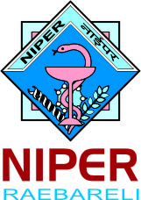
राष्ट्रीय औषधीय शिक्षा एवं अनुसंधान संस्थान, रायबरेली
National Institute of Pharmaceutical Education and Research
(An autonomous Institute under the Department of Pharmaceuticals, Ministry of Chemicals and Fertilizers, Govt. of India)
Transit Campus of NIPER – Raebareli, Bijnor- Sisendi Road, Sarojini Nagar, Lucknow (U.P.)-226002

Notice

Date: 17.11.2020
The Pre bid Meeting for EOI for design and development of new website to be held as per schedule below

Sl. No | EOI | Date | Time
1 | EOI for website development | 19.11.2020 | 04:00 P.M

Join on your computer or mobile app
Click here to join the meeting
Or Copy and paste below link in to web browser:
https://teams.microsoft.com/l/meetup-join/19%3ameeting_Zjc0YmY0NmQtZTg1MC00OTE1LWJmZTAtZDY0ZmUzYjhkMzcx%40thread.v2/0?context=%7b%22Tid%22%3a%227c8952c6-0c67-491e-847f-bd26ffd26d8d%22%2c%22Oid%22%3a%22bb4bc96e-f151-4478-b2a7-46a72f1a94fa%22%7d

Registrar

